A numerical study of dam-break waves in canonical configurations

George Johnson ^{1*}, Michel Horne² and Mike Lee¹

¹Department of Civil and Environmental Engineering, University of Iowa, Iowa City, IA 52240, USA
²Department of Civil Architecture and Environmental Engineering, University of Naples Federico II, Naples, 80125, Italy
*Corresponding author: michael_horne@uiowa.edu

Keywords (up to 5 max.): large eddy simulations, impact force, non-Newtonian fluid

Introduction
Please provide a one or two paragraphs introduction.

Methods
The computation domain in the simulations is L=$110h_{0}$long, B=1.5$h_{0}$wide and H=1.5$h_{0}$ high, where $h_{0}$ is the initial height of the lock region containing the wave fluid. The lock gate is situated at ${x/h}_{0}=0$ (Fig. 1).
(Fig. 1b,c).

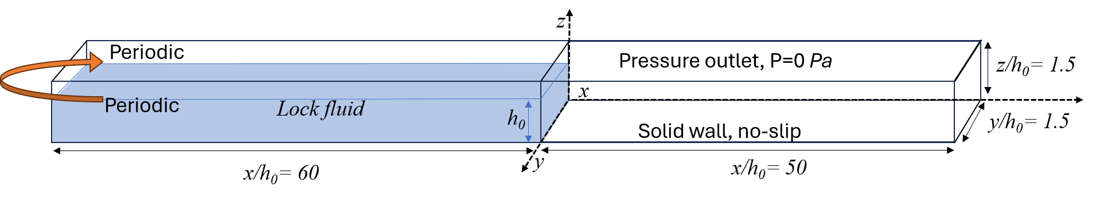
Fig. 1. Sketch of the computational domain and its dimensions. View of the channel showing the initial location and depth, $h_{0}$, of the wave fluid and the boundary conditions.
(Note: for all images please ensure they are high quality, use .jpg or .png format with minimum resolution of 300 dpi)

Several test cases (see Table 1) were run with non-Newtonian fluids.

Table 1. Main parameters of the test cases.
Case | ρ (Kg/m⁻³) | U (m/s) | Re (-) | h/d
N1 | 1000 | 1.8 | 140,000 | 20
N2 | 1064 | 2.2 | 230,000 | 50

The reference Reynolds number is defined as:
$Re=\frac{ρU_{0}h_{0}}{μ_{0}}=\frac{ρU_{0}^{2-n}h_{0}^{n}}{k}$ (1)
where $μ_{0}=k{\left(\frac{U_{0}}{h_{0}}\right)}^{n-1}$ denotes the reference dynamic molecular viscosity for power-law fluids. In the clear water case, $μ_{0}$ denotes the (water) dynamic viscosity. For uniform conditions in a wide channel, i.e. two–dimensional steady parallel flow conditions, a Reynolds number $Re'=$ $\frac{ρV_{u}D}{μ_{0}}$ can be defined with the hydraulics diameter D = ${4h}_{u}$, where $h_{u}$ is the uniform flow depth and $V_{u}$ is the corresponding depth-averaged streamwise velocity (see Patel et al., 2010).

Results
The velocity profile shown in Figure 2a shows a boundary layer formation and overshoot in the shear layer above the canopy and a significantly reduced and nearly vertical velocity profile within the canopy. The in-canopy velocity magnitude is 26% of the free-stream velocity, which is well predicted by both models. Figure 2b shows that the velocity phase lead increases throughout the shear layer and reaches a maximum value of about 70 degrees within the canopy, which is also well predicted by the linear and nonlinear model solutions. However, Figure 2c shows that only the nonlinear model reproduces the temporal variation of the in-canopy velocity accurately, as it captures the higher harmonic generation by the canopy.
Fig. 2. Grid dependency study for Case 5. a) Nondimensional temporal variation of the front position; b) Nondimensional streamwise velocity profile at section x/h₀= 12.5 when the front is situated at x_{f}/h₀ = 25.

A grid sensitivity analysis was conducted. As an example, results for $Case$ 5 are discussed. Figure 2 shows the temporal evolution of the dimensionless front position, x_{f}/h₀, and the profile of the spanwise averaged velocity at x/h₀= 12.5 and x_{f}/h₀ = 25 in wall coordinates (U⁺ = U/u_{τ} and z⁺ = z u_{τ}/ν_{w},, where U(x,z) is dimensional, spanwise-averaged velocity profile, u_{τ}(x) is the local bed friction velocity and ν_{w}(x) is the kinematic molecular viscosity at the channel bed). The temporal evolution of the front position (Fig. 2a) is close to identical in the simulations conducted with grids containing 18 million cells and 25 million cells. Significant differences are observed between the velocity profiles in Fig. 2b corresponding to the simulation performed using a coarse mesh containing close to 9 million cells and the two other simulations conducted on meshes containing more than 18 million cells.

Conclusions
Please provide a short paragraph summarizing the main findings.

Acknowledgements (If necessary)
This work was supported by ….

References (please use APA referencing style)
Patel, V. J. & Rajendran, V. K. (2010). An experimental study of dam break waves of non-Newtonian fluids. Water Resources Research, 140. (provide page numbers if available, provide paper ID if available)

